**WMRAT USER MANUAL**

**Overview** 2

**Development** 2

**Usage** 3

1..Model integration 3

2..Pipe failures 4

2.1. Single pipe failure (EPANET) 4

2.2. Single pipe failure (graph-based) 7

2.3. Multi pipe failure (graph-based) 9

3. Single pipe leakages 12

4. Segment criticality 17

5. Valve criticality 19

6. Downloading files 22

**License** 23

**Overview**

WMRAT (Water Management Resilience Analysis Toolkit) is a proof-of-concept web application that showcases and implements several scenarios in the context of urban water management resilience analysis. It is part of the project RESIST.

**Development**

This section explains how to start the local development server in a virtual Python environment ("venv"). Make sure that you also have Redis installed and running (systemctl start redis). The following third-party dependencies are used and are installed into the virtual environment:

* Django (v5.0)
* Django RQ (v1.15.1)
* WNTR (v1.1.0)

First check out this repository and switch into it:

$ git clone git@github.com:iut-ibk/wmrat.git

$ cd wmrat

Make the environment:

$ python -m venv venv

Activate it (observe how your shell prompt changes):

$ source venv/bin/activate

Install dependencies (we will use requirements later):

$ pip install django django_rq wntr

If everything went well you have now successfully installed the (Django) web application in your virtual environment. There is a script to reset the database (NOTE: this deletes all files, but is useful for debugging):

$ ./ops/reset_dev_env.sh

The login credentials for the test admin are admin and pass. Then use the following command to run the development environment:

$ ./ops/run_dev_env.sh

This starts the Django development server on localhost:8000 (the Django default port) and runs the required workers (that run the actual analyses).

**Usage**

This section explains the usage (Input functions, sample results (software based), sample results (GIS based)) of each criticality analysis with an artificially created water distribution network (WDN). The results/output is explained by an artificially created WDN in an Austrian Alpine city.

## 1..Model integration

Upload the required EPANET (.inp) file into the software with user specified coordinates for street view overlay.

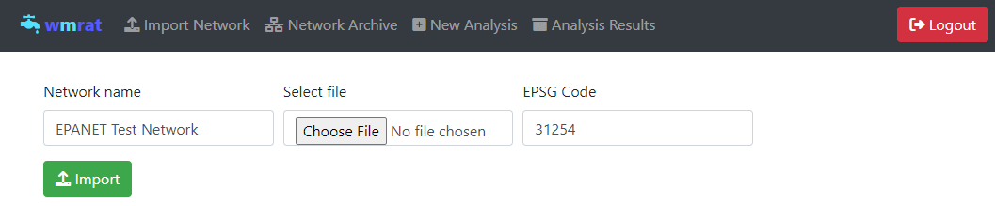

Figure : EPANET. inp File upload in WMRAT

## 2..Pipe failures

Single pipe failure analysis uses hydraulic-based criticality to assess node pressure, graph-based methods to identify overloaded pipes, and a hybrid approach for multiple failures to efficiently rank and analyze critical pipe combinations.

### 2.1. Single pipe failure (EPANET)

Allows users to estimate the number of critical nodes (nodes below the required pressure) during a single pipe failure using hydraulic-based demand driven EPANET criticality analysis. Results of pipes with no critical nodes are excluded from the results.

* + 1. **Input**   
       The users are required to input the required values for duration of EPANET analysis, required pressure for evaluation and minimum diameter below which are excluded in the analysis as seen in Table 1 and Figure 2.

Table : Input value details for single pipe failure (EPANET)

|  |  |  |  |  |
| --- | --- | --- | --- | --- |
| Name | Units | Purpose | Default | Provider |
| Duration | Seconds | Assess impact duration | 0 seconds | User |
| Required Pressure | Meters | Critical nodes are estimated below required pressure | 35.0 meters | User with solid fillUser with solid fillUser |
| Minimum Diameter | Meters | Excludes diameters below this threshold | 0.001 meters | User |

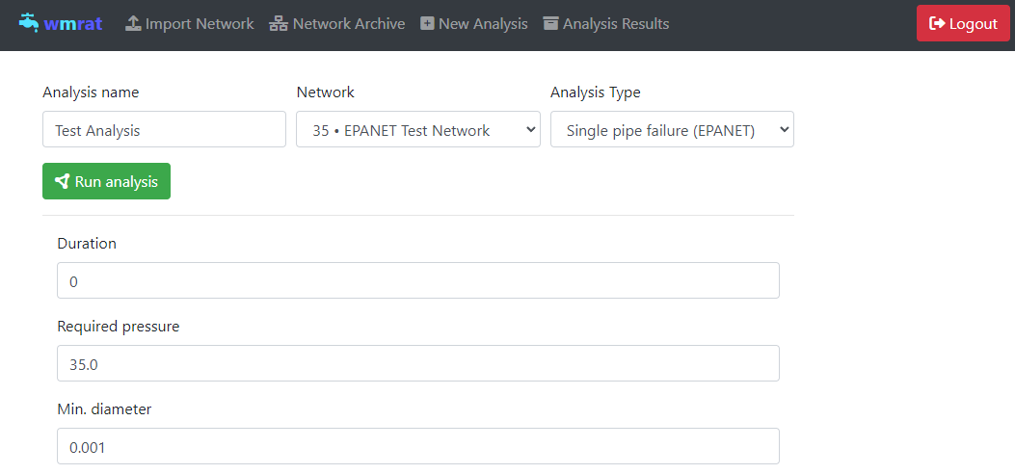

Figure : User input for single pipe failure (EPANET) on the web-platform

* + 1. **Sample results (Software based)**

The software-based results display the failed pipe in orange and the number of impacted junctions in red as illustrated in Figure 3. Users can either select pipes directly from the web platform table or click on them in the visual map.

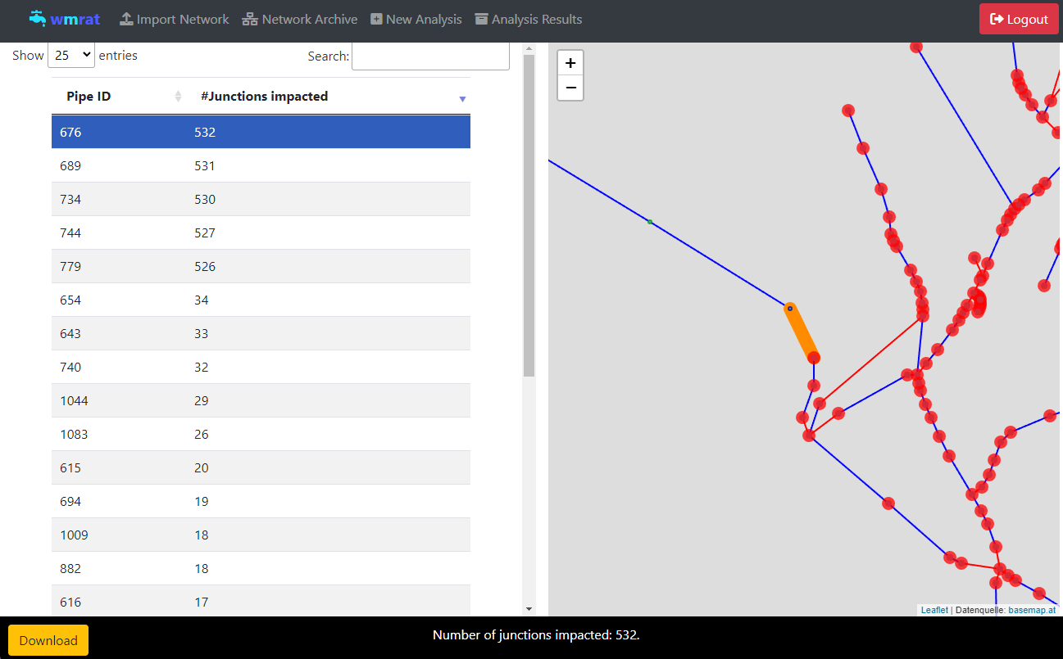

Figure : Sample results (software based) screenshot for the sample case study - single pipe (EPANET)

* + 1. **Sample results (GIS based)**

Downloading the .json file and exporting it to GIS can facilitate comprehensive visualization of the WDN and the critical pipelines as illustrated in Figure 4.



Figure : GIS visualization of the single pipe failure (EPANET) for the sample case study.

### 2.2. Single pipe failure (graph-based)

Allows users to estimate the rank of each pipe during a single pipe failure using graph-based criticality analysis.

* + 1. **Input**   
       The users are required to input the Tank name as per the .inp file as illustrated Table 2 and Figure 5. The number of tanks is user defined by pressing on Add as illustrated in Figure 5.

Table : Input value details for single pipe failure (graph-based)

|  |  |  |  |
| --- | --- | --- | --- |
| Name | Purpose | Default | Provider |
| Source | Calculate the shortest route and failure magnitudes to this node | 534 | User |
| Number of sources | For networks with multiple sources | 1 | User with solid fillUser with solid fillUser |

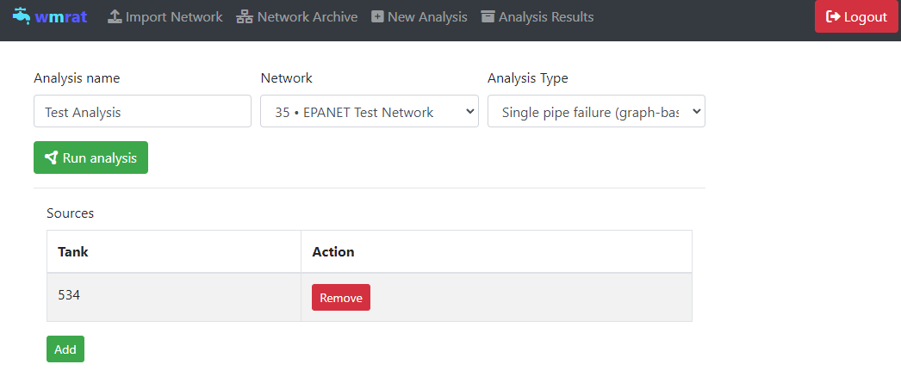

Figure : User input for single pipe failure (graph-based) on the web-platform

* + 1. **Sample results (Software based)**

The software-based results display the failed pipe in orange and the rank of failed pipe based on the failure magnitudes in Figure 6.

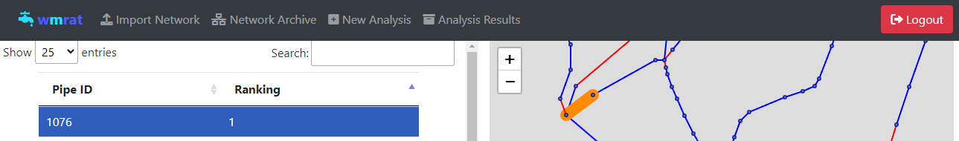

Figure : Sample results (software based) screenshot for the sample case study – single pipe failure (graph-based)

* + 1. **Sample results (GIS based)**

Downloading the .json file and exporting it to GIS facilitates a detailed visualization of the WDN, highlighting pipes based on their rankings derived from graph-based failure magnitudes (GBFM), as illustrated in Figure 7.

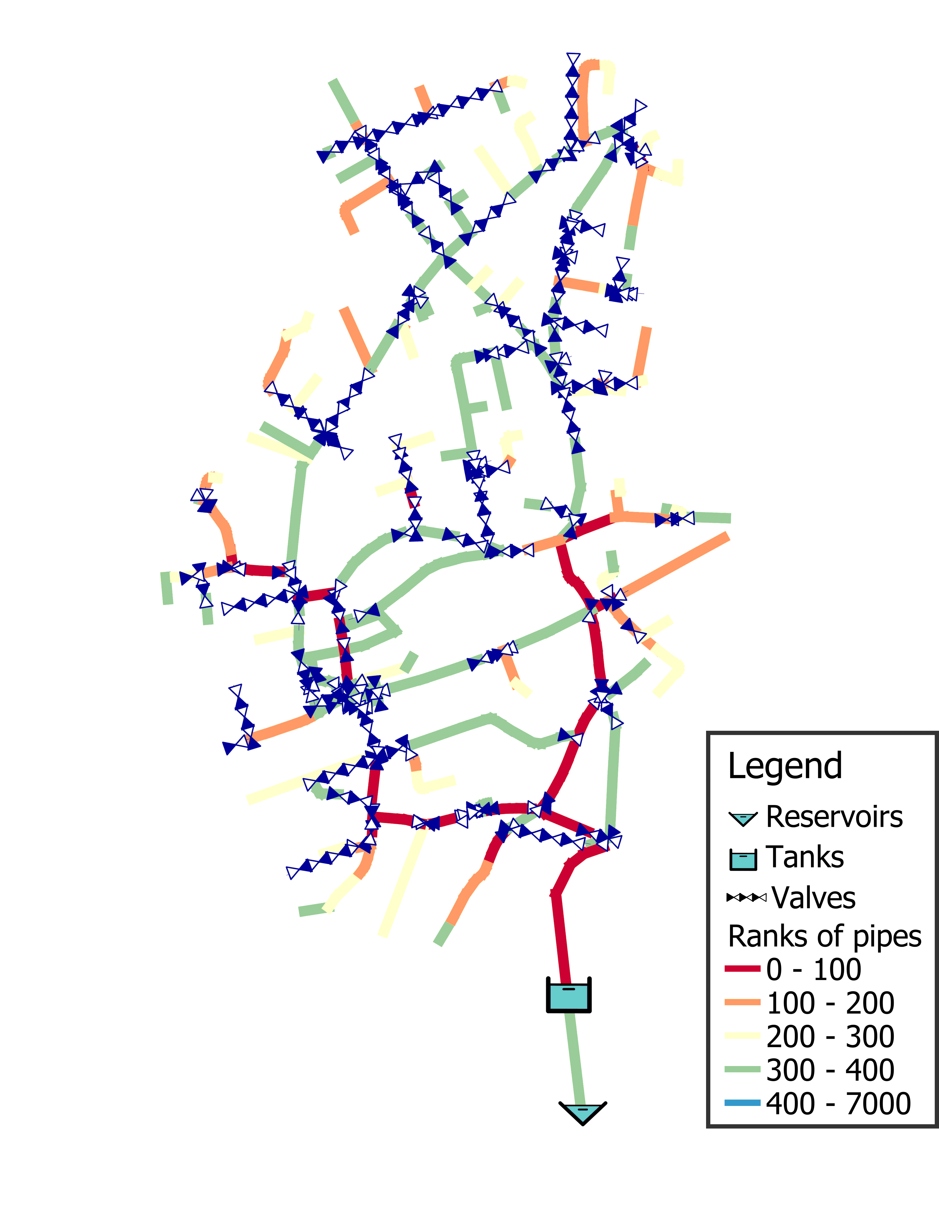

Figure : GIS visualization of single pipe failure (graph) for the sample case study.

### 2.3. Multi pipe failure (graph-based)

Allows users to estimate the rank on each pipe combinations during the respective pipe failure using graph-based criticality analysis and also rank and compute the amount of demand fulfilled in the network for the combinations based on hydraulic-based pressure driven analysis. The graph-based criticality analysis effectively filters out the combinations with no impact on the WDN making it faster than hydraulic-based criticality analysis.

* + 1. **Input**   
       The users are required to input the Tank name as per the .inp file as illustrated in Table 3 and Figure 8. The number of combinations of pipes that is required to be analyzed as per user requirements.

Table : Input value details for multi pipe failure (graph-based)

|  |  |  |  |
| --- | --- | --- | --- |
| Name | Purpose | Default | Provider |
| Source | Calculate the shortest route and failure magnitudes to this node | 534 | User |
| Number of combinations | To create the required number of pipe combinations | 2 | User with solid fillUser |

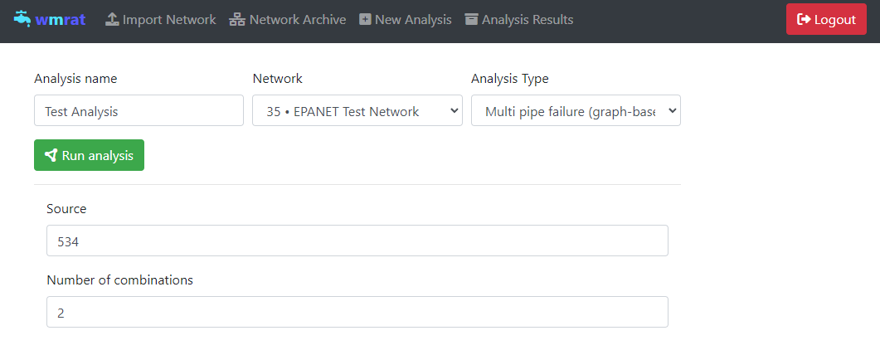

Figure : User input for multi pipe failure (graph-based) on the web-platform

* + 1. **Sample results (Software based)**

The software-based results display the failed pipes in orange and green as illustrated in Figure 9 with ranks of graph and hydraulic-based criticality analysis and demand fulfilled from hydraulic-based criticality analysis in the software table.

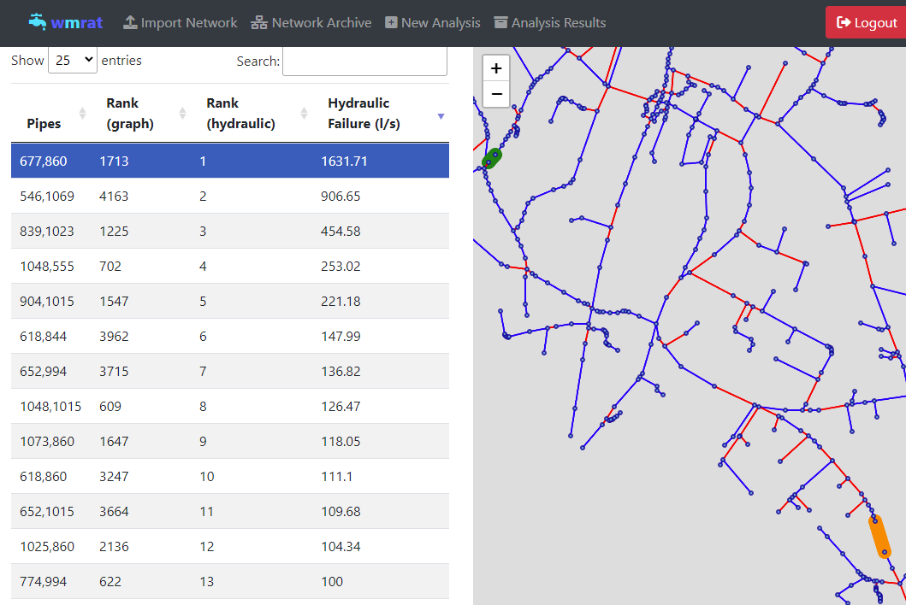

Figure : Sample results (software based) screenshot for the sample case study –multi pipe failure (graph-based)

* + 1. **Sample results (GIS based)**

The results for GIS based visualization is complicated for the entire network as the results are based on combinations and not on a single source from the attributes table.

## 3. Single pipe leakages

Allows users to estimate the pipe leakages in seconds, minutes and time to empty 10 m3 of water from the tank due leaks in single pipes.

**3.1. Input**   
The users are required to input the Tank name, tank outflow pipe ID (pipe in direction of flow) as per the .inp file, number of tanks and material/area/exponent values as illustrated in Table 4 and Figure 10. The material/area/exponent values are literature-based values as illustrated in Table 5 and Table 6.

Table : Input value details for single pipe leakage

|  |  |  |  |  |
| --- | --- | --- | --- | --- |
| Name | Unit | Purpose | Default | Provider |
| Tank name | String | Calculate the volume of tank | TANK_1 | User |
| Tank outflow pipe ID | String | To access the main outflow pipe | 1086_b | User with solid fillUser with solid fillUser |
| Number of tanks | Number | Calculate volume and leakage affect for multi sources | 1 | User with solid fillUser |
| Material/Area/Exponent | Varied | Calculation of emitter coefficient and emitter exponent | Figure 10 | User with solid fillUser |

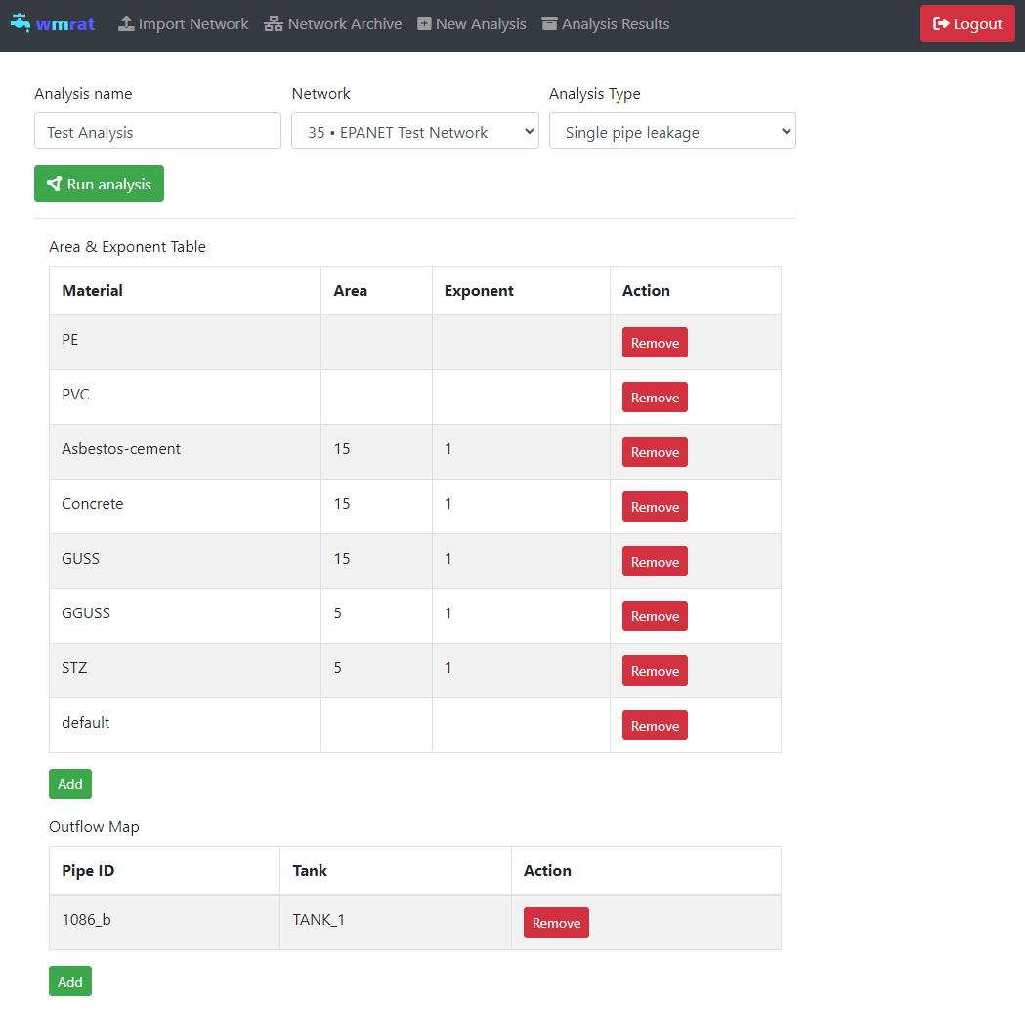

Figure : User input for single pipe leakages on the web-platform

Table : Aperture area A (cm²) for different fault modes for an Austrian transmission grid (modified from Friedl, et al. 2012)

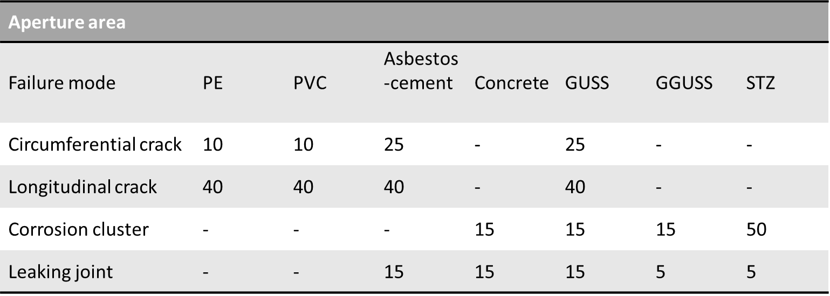

Table : Emitter exponents derived from the literature for different failure modes (modified from Friedl et al., 2012)

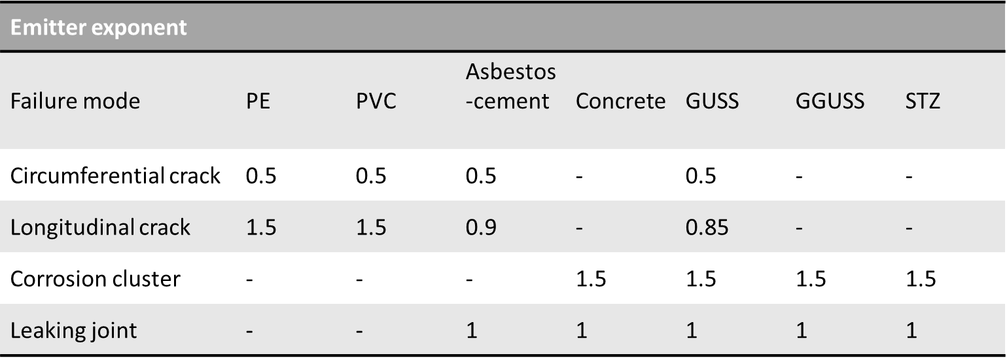

**References:**

*Friedl, F., Möderl, M., Rauch, W., Liu, Q., Schrotter, S., Fuchs-Hanusch, D., 2012. Failure propagation for large-diameter transmission water mains using dynamic failure risk index, World environmental and water resources Congress 2012: Crossing boundaries, pp. 3082-3095.*

**3.2. Sample results (Software based)**

The software displays the failed pipe in orange, along with the tank volume to which the pipe is connected. The leakage rates are shown in liters per second and per minute, as well as the time required to empty 10 m³ of water from the connected tank, as illustrated in Figure 11.

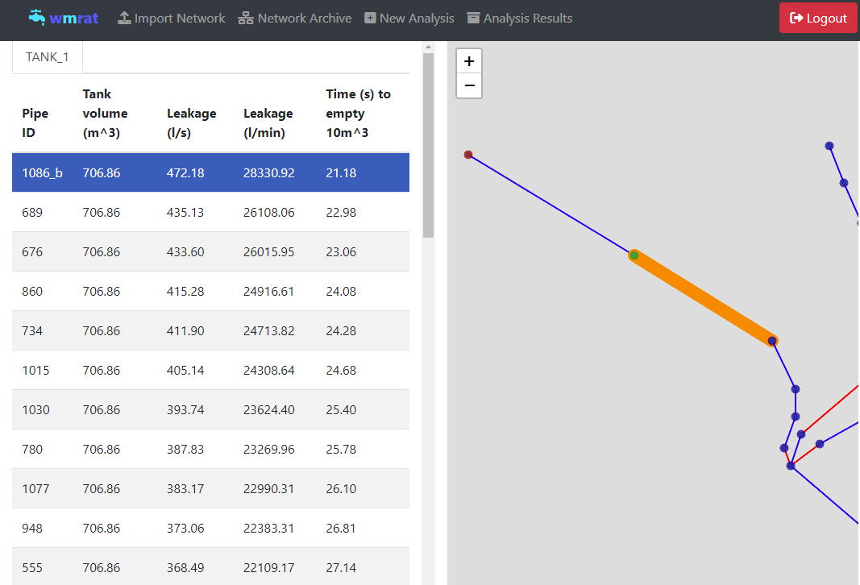

Figure : Sample results (software based) screenshot for the sample case study – single pipe leakage.

**3.3. Sample results (GIS based)**

Downloading the .json file and exporting it to GIS facilitates a comprehensive visualization of the WDN and identifies critical pipelines that may be vulnerable to various types of leaks, as depicted in Figure 12.

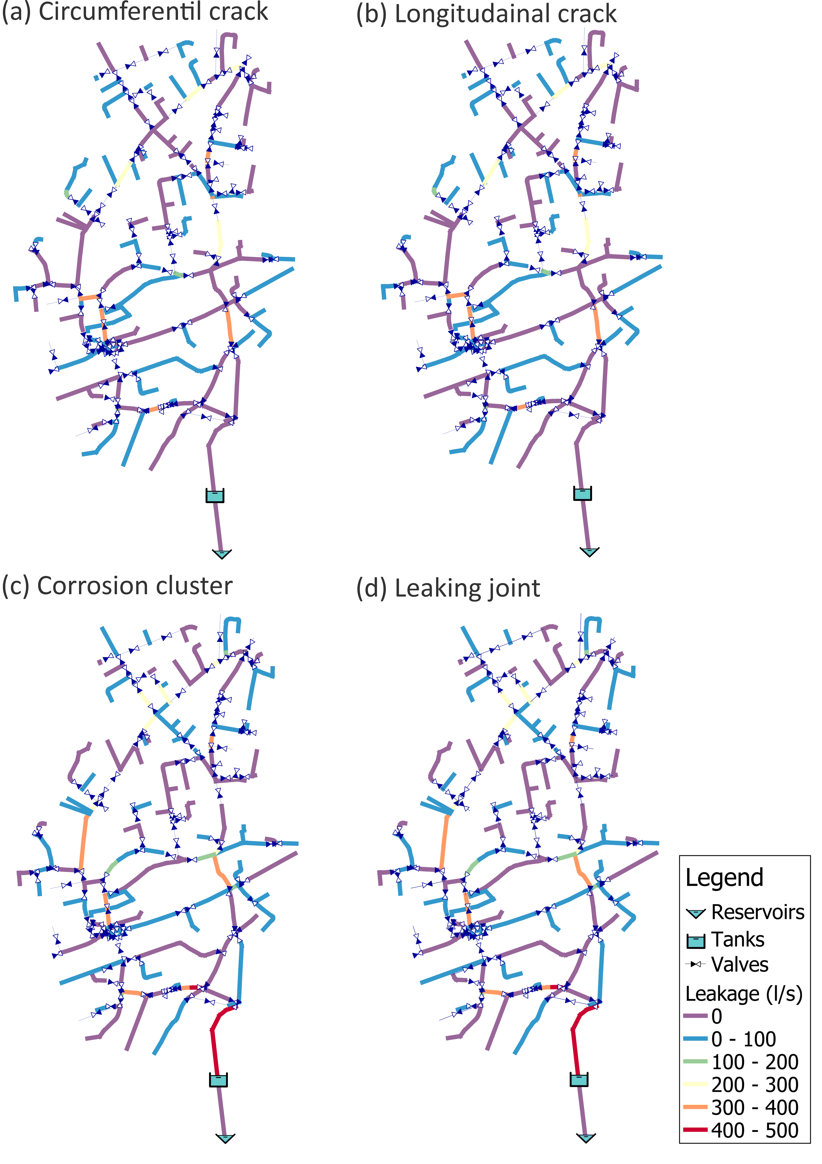

Figure : Results for single pipe failure (EPANET) for artificially created WDN visualized on a GIS platform.

## 4. Segment criticality

Allows users to estimate the criticality of each segment based of pressure driven hydraulic EPANET analysis by estimating the amount demand fulfilled during a segment failure.

**4.1. Input**   
There is no user input required; however, the WDN must have isolation values (GPV or FCV) to function properly. Otherwise, the entire WDN will be considered as a single segment.

Table : Input value details for single pipe leakage

|  |  |  |
| --- | --- | --- |
| Name | Purpose | Provider |
| Isolation valves | Creation of segments | Monitor with solid fill System |

**3.2. Sample results (Software based)**

The software displays the segment in green, directly impacted nodes in red (inside the segment), indirectly impacted nodes due to lack of supply of water demand compared to the original state. The software table also displays the demand not fulfilled, number of directly and indirectly impacted nodes as illustrated in Figure 13.

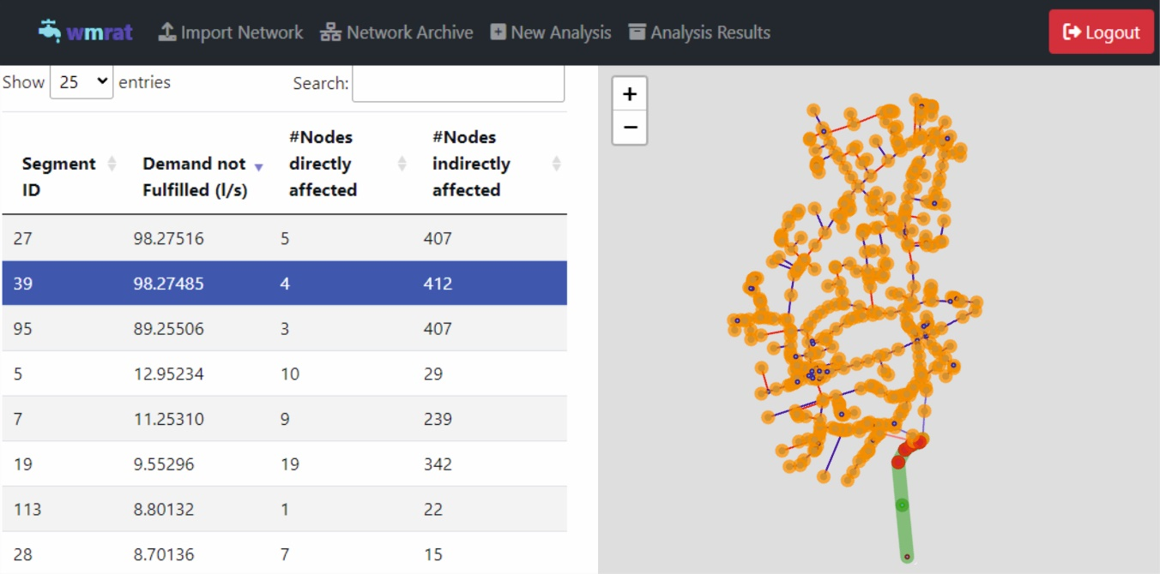

Figure : Sample results (software based) screenshot for the sample case study – segment criticality.

**4.3. Sample results (GIS based)**

The results for GIS based visualization is complicated for the entire network as the results are based on combinations (segments are combinations of pipes, nodes and valves) and not on a single source from the attributes table.

## 5. Valve criticality

Allows users to estimate the criticality of each valve based of pressure driven hydraulic EPANET analysis by estimating the amount demand fulfilled during a valve failure.

**5.1. Input**   
There is no user input required; however, the WDN must have isolation values (GPV or FCV) to function properly. During analysis segments connected to the valves are closed for finding the demand not fulfilled in nodes. Closing the segments would isolate the valve for repairs.

Table : Input value details for single pipe leakage

|  |  |  |
| --- | --- | --- |
| Name | Purpose | Provider |
| Isolation valves | Creation of segments | Monitor with solid fill System |

**5.2. Sample results (Software based)**

The software displays the failed valve in green, directly impacted nodes in red (inside the two segments closed), indirectly impacted nodes due to lack of supply of water demand compared to the original state. The software table also displays the demand not fulfilled, number of directly and indirectly impacted nodes as illustrated in Figure 14.

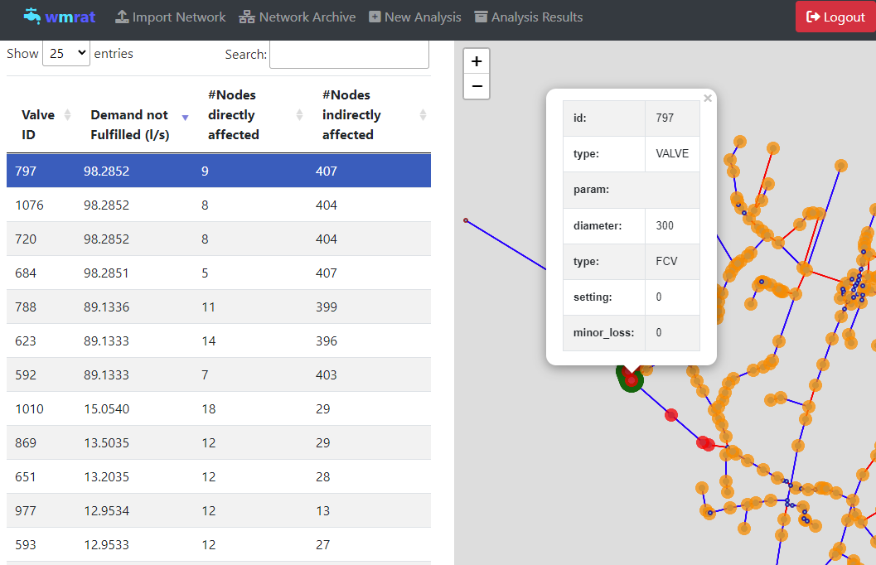

Figure : Sample results (software based) screenshot for the sample case study –valve criticality.

**5.3. Sample results (GIS based)**

Downloading the .json file and exporting it to GIS enables a detailed visualization of the WDN and highlights critical valves based on the percentage of demand that is not met under current conditions, as illustrated in Figure 15. The percentages of unmet demand are represented on a color gradient, with blue indicating no impact and red signifying a significant percentage of unmet demand.



Figure : Results for valve criticality for artificially created WDN visualized on a GIS platform.

## 6. Downloading files

The results can be viewed on the web platform by clicking the "Show" button, and downloaded as an Excel or JSON file by clicking the "Download" button, as shown in Figure 16.

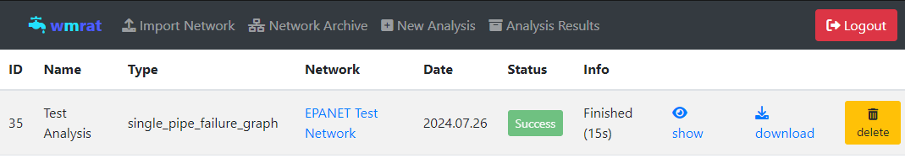

Figure : Analysis results output tab in WMRAT

**License**

AGPLv3